A
Major Project

On

NON- INVASIVE BLOOD GROUP CLASSIFICATION USING FINGERPRINT IMAGES AND DEEP RESIDUAL LEARNING
(Submitted in partial fulfilment of the requirements for the award of Degree)

BACHELOR OF TECHNOLOGY
In

COMPUTER SCIENCE AND ENGINEERING
By

J Revanth Kumar (227R1A0592)
E Sravanthi (227R1A0581)
Gousiya Begum (227R1A0586)

Under the Guidance of

Dr. K. SHILPA
(Assistant Professor)


DEPARTMENT OF COMPUTER SCIENCE AND ENGINEERING
CMR TECHNICAL CAMPUS
UGC AUTONOMOUS
(Accredited by NAAC, NBA, Permanently Affiliated to JNTUH, Approved by AICTE, New Delhi)
Recognized Under Section 2(f) & 12(B) of the UGCAct.1956, Kandlakoya (V), Medchal Road, Hyderabad-501401.
April, 2026.

DEPARTMENT OF COMPUTER SCIENCE AND ENGINEERING


CERTIFICATE

This is to certify that the project entitled “NON-INVASIVE BLOOD GROUP CLASSIFICATION USING IMAGES AND DEEP RESIDUAL LEARNING”
being submitted by J Revanth Kumar (227R1A0592), E Sravanthi (227R1A0581) & Gousiya Begum (227R1A0586) in partial fulfilment of the requirements for the award of the degree of B.Tech in Computer Science and Engineering to the Jawaharlal Nehru Technological University Hyderabad, during the year 2025-26.

The results embodied in this project have not been submitted to any other University or Institute for the award of any degree or diploma.

Dr. K. Shilpa Dr. Nuthanakanti Bhaskar Assistant Professor HoD
INTERNAL GUIDE

Dr. A. Raji Reddy Signature of External Examiner DIRECTOR

Submitted for viva voice Examination held on

ACKNOWLEDGEMENT
We take this opportunity to express our gratitude to the people who have been instrumental in the successful completion of this project, we take this opportunity to express our profound gratitude and deep regard to our guide Dr K Shilpa , Assistant Professor for his exemplary guidance, monitoring and constant encouragement throughout the project work. The blessing, help and guidance given by him shall carry us a long way in the journey of life on which we are about to embark.

We take this opportunity to extend our heartfelt appreciation to the Project Review Committee (PRC) Coordinators—Dr K Maheswari,Mr B Sekhar,Dr K Shilpa, Mrs D Sandhya Rani,Dr S Suma—for their unwavering support, insightful guidance, and valuable inputs, which played a crucial role in steering this project through its various stages.

Our sincere appreciation also goes to Dr. Nuthanakanti Bhaskar, Head, for his encouragement and continuous support in ensuring the successful completion of our project.

We are deeply grateful to Dr. A. Raji Reddy, Director, for his cooperation throughout the course of this project. Additionally, we extend our profound gratitude to Sri. Ch. Gopal Reddy, Chairman, Smt. C. Vasantha Latha, Secretary and Sri. C. Abhinav Reddy, Vice- Chairman, for fostering an excellent infrastructure and a conducive learning environment that greatly contributed to our progress.
We also acknowledge and appreciate the guidance and assistance provided by the faculty and staff of CMR Technical Campus, whose contributions have been invaluable in bringing this project to fruition.

Lastly, we sincerely thank our families for their unwavering support and encouragement. We also extend our gratitude to the teaching and non-teaching staff of CMR Technical Campus for their guidance and assistance. Their contributions, along with the support of everyone who helped directly or indirectly, have been invaluable in the successful completion of this project.
J Revanth Kumar (227R1A0592) E Sravanthi (227R1A0581) Gousiya Begum (227R1A0586)

VISION AND MISSION

INSTITUTE VISION:
To Impart quality education in serene atmosphere thus strive for excellence in Technology and Research.

INSTITUTE MISSION:
- To create state of art facilities for effective Teaching- Learning Process.

- Pursue and Disseminate Knowledge based research to meet the needs of Industry & Society.

- Infuse Professional, Ethical and Societal values among Learning Community.

DEPARTMENT VISION:
To provide quality education and a conducive learning environment in computer engineering that foster critical thinking, creativity, and practical problem-solving skills.

DEPARTMENT MISSION:
- To educate the students in fundamental principles of computing and induce the skills needed to solve practical problems.

- To provide State-of-the-art computing laboratory facilities to promote industry institute interaction to enhance student’s practical knowledge.

- To inculcate self-learning abilities, team spirit, and professional ethics among the students to serve society.

ABSTRACT

This project is titled as “Blood Group Detection Using Finger Print”. Blood group detection plays a crucial role in medical emergencies, surgeries, blood transfusions, and organ transplantation. Traditionally, blood typing is performed through invasive laboratory tests involving blood samples, which are time-consuming, require skilled technicians, and can be prone to human error. To overcome these limitations, this project presents a novel and non- invasive approach for blood group detection using fingerprint analysis, leveraging the unique biometric features of human fingerprints in combination with machine learning techniques. This system aims to provide a fast, accurate, and cost-effective alternative to conventional blood testing methods. The fundamental concept of this research is based on the hypothesis that certain physiological characteristics reflected in fingerprint patterns correlate with specific blood groups. Each individual’s fingerprint contains distinct ridge patterns, loops, whorls, and arches influenced by genetic and biological factors, including those related to blood group antigens. By capturing and analyzing these patterns using image processing and artificial intelligence, it is possible to establish a predictive relationship between fingerprint features and corresponding blood group classifications (A, B, AB, or O) along with Rh factor determination (positive or negative). In this system, fingerprint images are first collected using a biometric scanner and prepossessed to remove noise, enhance contrast, and normalize ridge structures. The region of interest (ROI) is extracted, followed by feature extraction using image processing techniques such as Garbo filters, ridge orientation estimation, and minutiae detection. The extracted features are then used as input data for machine learning algorithms—such as Support Vector Machines (SVM), Random Forest, or Convolution Neural Networks (CNN)—to classify the blood group of the individual. The model is trained on a data set containing labelled fingerprints with known blood groups, ensuring accurate pattern learning.
LIST OF FIGURES

FIGURE NO | FIGURE NAME | PAGE NO
Figure 2.7 | Gantt Chart of Project Scheduling | 23
Figure 3.1 | Project Architecture of Blood Group Detection using Fingerprint | 24
Figure 3.2 | Data flow Diagram of Non- Invasive Blood Group Classification Using Fingerprint Images and Deep Residual Learning | 27
Figure 4.1.1 | Data set directory structure with folders 'Safe Content and Inappropriate Content' having all the training examples | 31
Figure 4.1.2 | Screenshot of the "A- Negative" Folder Showing Sample Image Files | 31
Figure 4.1.3 | Screenshot of the "A+ Positive" Folder Showing Sample Image Files. | 32
Figure 4.1.4 | Screenshot of the "AB+ Positive" Folder Showing Sample Image File. | 32
Figure 4.1.5 | Screenshot of the "AB- Negative" Folder Showing Sample Image Files. | 33
Figure 4.1.6 | .Screenshot of the "B+ Positive"  Folder Showing Sample Image Files. | 33
Figure 4.1.7 | .Screenshot of the "B-Negative" Folder Showing Sample Image Files. | 34
Figure 4.1.8 | Screenshot of the "O+ Positive" Folder Showing Sample Image Files. | 34
Figure 4.1.9 | Screenshot of the "O- Positive" Folder Showing Sample Image Files. GUI/Main Interface of Non- | 35
Figure 5.1 | GUI/Main Interface of Non- Invasive Blood Group Classification Using Fingerprint Images and Deep Residual Learning | 42
Figure 5.2 | Loaded sample image of Non- Invasive Blood Group Classification Using Fingerprint Images and Deep Residual Learning | 43
Figure 5.3 | Data set of Non-Invasive Blood Group Classification Using Fingerprint Images and Deep Residual Learning | 43

LIST OF TABLES

TABLE NO | TABLE NAME  23 | PAGE NO
Table 2.7.1 | Project Scheduling | 23
Table 6.2.1 | Uploading Dataset | 45
Table 6.2.2 | Classification | 45

TABLE OF CONTENTS

ABSTRACT |  |  |  | I
LIST OF FIGURES |  |  |  | II
LIST OF TABLES |  |  |  | IV
1. | INTRODUCTION |  |  | 1
 | 1.1 | PROJECT PURPOSE |  | 1
 | 1.2 | PROJECT FEATURES |  | 2
2. | LITERATURE SURVEY |  |  | 4
 | 2.1 | REVIEW OF RELATED WORK |  | 16
 | 2.2 | DEFINITION OF PROBLEM STATEMENT |  | 21
 | 2.3 | EXISTING SYSTEM |  | 21
 | 2.4 | PROPOSED SYSTEM |  | 21
 | 2.5 | OBJECTIVES |  | 22
 | 2.6 | HARDWARE & SOFTWARE REQUIREMENTS |  | 22
 |  | 2.6.1 | HARDWARE REQUIREMENTS | 22
 |  | 2.6.2 | SOFTWARE REQUIREMENTS | 22
 | 2.7 | PROJECT SCHEDULING |  | 23
3. | SYSTEM ARCHITECTURE & DESIGN |  |  | 24
 | 3.1 | PROJECT ARCHITECTURE |  | 24
 | 3.2 | DESCRIPTION |  | 24
 | 3.3 | DATA FLOW DIAGRAM |  | 25
4. | IMPLEMENTATION |  |  | 28
 | 4.1 | ALGORITHMS USED |  | 28
 | 4.2 | SAMPLE CODE |  | 36
5. | RESULTS & DISCUSSION |  |  | 42
6. | VALIDATION |  |  | 45
 | 6.1 | INTRODUCTION |  | 47
 | 6.2 | TEST CASES |  | 45
 |  | 6.2.1 | UPLOADING DATASET | 45
 |  | 6.2.2 | CLASSIFICATION | 45
7. | CONCLUSION & FUTURE ASPECTS |  |  | 47
 | 7.1 | PROJECT CONCLUSION |  | 47
 | 7.2 | FUTURE ASPECTS |  | 48
8. | BIBLIOGRAPHY |  |  | 49
 | 8.1 | REFERENCES |  | 50
 | 8.2 | GITHUB LINK |  | 52
 | 8.3 | PUBLICATIONS |  | 53

1 . INTRODUCTION

Blood group identification is a vital process in the medical field, as it plays a crucial role in blood transfusions, organ transplants, accident treatments, and various surgical procedures. Traditionally, blood group detection is carried out through invasive laboratory techniques that require drawing a blood sample and testing it with antigen-specific reagents. Although this method is accurate, it involves time, resources, and skilled personnel, and may cause discomfort or risk of infection to the patient. In emergency situations, such as accidents or natural disasters, quick identification of a person’s blood group can be life-saving. Therefore, there is a growing need for a faster, safer, and non-invasive method for blood group detection.
The human fingerprint is a unique biometric trait that remains unchanged throughout life. Fingerprints contain distinct patterns such as loops, whorls, and arches, which are determined by genetic and biological factors. Research has shown that there is a correlation between blood group types and certain fingerprint pattern characteristics. This relationship provides a foundation for developing a system that can predict a person’s blood group using fingerprint analysis.

PROJECT PURPOSE

The main purpose of this project, “Blood Group Detection Using Fingerprint,” is to develop a fast, reliable, and non-invasive system to identify a person’s blood group using fingerprint analysis. In traditional methods, blood group determination requires collecting a blood sample and performing laboratory tests, which can be time-consuming, costly, and uncomfortable for individuals. This project aims to eliminate those challenges by using biometric technology to detect blood groups instantly and without physical intrusion.
The project is based on the scientific observation that certain fingerprint pattern such as loops, whorls, and arches—show a correlation with specific blood group types. By capturing and analyzing these fingerprint patterns with advanced image processing and machine learning algorithms, it becomes possible to predict the blood group of an individual accurately.The key objective is to create a system that can serve as a quick diagnostic tool in medical emergencies, especially where blood group information is urgently needed and laboratory facilities are not available. Additionally, this system can be integrated into digital healthcare records, making it easier to maintain personal medical data securely and efficiently.

PROJECT FEATURES

The project “Blood Group Detection Using Fingerprint” introduces an innovative, non- invasive method for determining an individual’s blood group using fingerprint analysis. The system integrates biometric technology, image processing, and machine learning to provide a fast, secure, and accurate alternative to traditional blood testing methods. The key features of this project are described below:
The project “Blood Group Detection Using Fingerprint” introduces an innovative, non- in massive method for determining an individual’s blood group using fingerprint analysis. The system integrates biometric technology, image processing, and machine learning to provi de a fast, secure, and accurate alternative to traditional blood testing methods. The key features of this project are described below.
1.Non-Invasive Detection:
The system eliminates the need for blood sampling, making the process painless, safe, and hygienic. It only requires a fingerprint scan to identify the blood group, thus reducing the risk of infection and discomfort.
2.Biometric-Based Identification:
Each person’s fingerprint is unique and permanent. The project uses this biometric trait to establish a relationship between fingerprint ridge patterns and corresponding blood groups, ensuring high reliability and security.
3.Image Processing Techniques:
Advanced image processing methods are applied to extract significant features from the fingerprint image, such as ridges, minutiae points, loops, whorls, and arches. These features are essential for accurate classification and prediction.
4.Machine Learning Integration:
The project utilizes machine learning algorithms like Support Vector Machine (SVM), Random Forest, or Convolution Neural Networks (CNN) to analyze the extracted fingerprint features and classify the blood group accurately
5.Fast and Automated Results:
The system is designed to produce immediate results after fingerprint scanning, making it suitable for emergency medical situations and real-time applications.

6.User-Friendly Interface:
The project includes a simple and interactive interface that allows users or health-care professionals to easily input fingerprint data and view the detected blood group instantly.Overall, the project combines technology and health-care innovation to create a smart, efficient, and contact-based solution for rapid blood group detection, suitable for hospitals, blood banks, and emergency services.

2.LITERATURE SURVEY
The identification of blood groups has always played a crucial role in medical science, especially in situations involving blood transfusions, organ transplantation, forensic analysis, and emergency treatments. Traditionally, the process of identifying an individual’s blood group has relied on serological methods that involve invasive procedures, reagent-based testing, and trained laboratory personnel. However, with the advancement of technology in biometrics, image processing, and machine learning, researchers have begun exploring non- invasive approaches to biological data prediction, including the detection of blood group through fingerprint patterns. This literature survey presents an overview of existing research, theories, and methods related to fingerprint analysis, biometric applications, and their potential correlation with blood group detection.
- Background on Blood Group Systems:

The most widely recognized blood group classification systems are the ABO system and the Rh factor system, discovered by Karl Landsteiner in the early 1900s. The ABO system divides blood into four major groups—A, B, AB, and O—based on the presence or absence of antigen A and B on the surface of red blood cells. The Rh factor further classifies these into positive (+) or negative (−) groups depending on the presence of the Rh antigen. Blood group determination is critical in preventing transfusion-related complications, such as hemolytic reactions or mismatched blood transfusions.Although conventional testing methods are reliable, they require invasive sample collection, laboratory facilities, and time. As a result, researchers have explored alternative, non-invasive approaches that leverage physiological and genetic correlations between blood group traits and other human features such as fingerprints, iris, or facial patterns.
- Fingerprint Patterns and Their Biological Significance:
Fingerprints are one of the most reliable and unique biometric traits used for personal identification. Each individual possesses distinct fingerprint patterns that remain unchanged throughout life, making them a dependable source of biometric data. Fingerprint patterns are generally classified into three major types: loops, whorls, and arches, with several subcategories such as plain arch, tented arch, radial loop, ulnar loop, and double whorl.According to the findings of Cummins and Midlo (1943), fingerprints are formed during the fetal stage (around the 10th week of gestation) and are influenced by both genetic and environmental factors.

Since blood group antigens are also genetically inherited, researchers hypothesized that there could be a possible correlation between fingerprint pattern types and blood group classifications.
- Early Research on the Relationship Between Blood Group and Fingerprints:

The first studies examining the relationship between dermatoglyphics (fingerprint patterns) and blood group were conducted in the mid-20th century. Holt (1968) and later Mavalankar and colleagues (1977) investigated the frequency of fingerprint patterns among individuals with different blood groups. They observed certain tendencies, such as a higher occurrence of loop patterns in blood group O and whorl patterns in group B, though the correlations were not absolute.In the 1980s and 1990s, several studies were conducted to statistically analyze this relationship using larger sample sizes. For example, Kumbhar et al. (1999) found that the frequency of loop patterns was higher among individuals with blood group O+, while arches were less common in AB blood groups. Although results varied among populations, most studies confirmed the existence of a genetic linkage between fingerprint formation and blood group inheritance.With the advancement of digital imaging and biometric technology, fingerprint analysis has evolved beyond physical observation. Modern systems use optical sensors, capacitive sensors, and ultrasonic scanners to capture high-resolution fingerprint images. Image processing algorithms are then applied to extract key features such as ridges, minutiae points, ridge endings, and bifurcations.According to Maltoni et al. (2003), fingerprint recognition systems consist of several stages: image acquisition, preprocessing, feature extraction, and matching. Preprocessing techniques like image enhancement, noise reduction, and normalization are used to improve the quality of captured images. Algorithms such as Gabor filters, Fast Fourier Transform (FFT), and Histogram Equalization are widely used for enhancement and feature extraction.In the context of blood group detection, these fingerprint features are not used for identity verification but rather as biological indicators correlated with genetic traits. Researchers began applying pattern recognition and machine learning techniques to study these correlations quantitatively.

- Machine Learning and Pattern Recognition in Biomedical Applications:

The integration of machine learning (ML) and artificial intelligence (AI) in medical diagnostics has opened new possibilities for automated health prediction. ML algorithms can identify patterns and relationships in complex datasets that are difficult for humans to detect manually. Techniques such as Support Vector Machines (SVM), K-Nearest Neighbors (KNN), Random Forests, and Convolutional Neural Networks (CNN) have shown great 4. Biometric Applications and Fingerprint Analysis Techniques potential in areas like disease detection, medical imaging, and genetic analysis.For example, in studies like that of Sharma et al. (2017), ML models were trained to classify individuals’ blood groups using fingerprint images as input features. The process involved converting fingerprint images into numerical feature vectors representing ridge density, minutiae count, and pattern types. The SVM classifier achieved significant accuracy, indicating a measurable relationship between fingerprint characteristics and blood group type.Similarly, research by Ahamed et al. (2018) employed a CNN-based model to automatically extract fingerprint features and classify blood groups. Deep learning methods outperformed traditional manual feature extraction approaches due to their ability to learn complex hierarchical features directly from image data.
- Correlation Studies in Different Populations:

Various researchers have examined fingerprint–blood group correlations across populations and ethnic groups. For instance, Reddy and colleagues (2010) analyzed 500 subjects in India and observed that individuals with blood group O had a higher percentage of loop patterns, while those with blood group B showed more whorls. Another study by Mehta and Shah (2013) on 1,000 participants also supported similar findings.A comparative study by Oladipo et al. (2009) in the Nigerian population demonstrated consistent correlations between fingerprint ridge patterns and ABO blood groups. Although not sufficient for deterministic prediction, these findings reinforced the hypothesis that blood group-related genetic factors influence dermatoglyphic formation.In a more recent study, Sridevi et al. (2020) applied digital image processing and pattern recognition algorithms on a dataset of fingerprint images.They achieved over 85% accuracy in predicting blood group types, proving that computational analysis can strengthen earlier observational studies.

- Fingerprint-Based Healthcare and Security Applications
Fingerprint technology has already proven its efficiency in several fields including personal identification, attendance systems, access control, and mobile device security. In healthcare, fingerprint-based systems are increasingly used for patient record management, hospital check-ins, and electronic health record (EHR) access. Integrating blood group prediction into such systems can enhance medical readiness and streamline emergency treatments.
- Limitations of Previous Research

Despite significant progress, several limitations have been noted in earlier studies. Many traditional studies were based on small sample sizes or lacked sufficient diversity in population datasets. Correlations observed were often statistical rather than causal, meaning that fingerprint patterns alone cannot determine blood groups with 100% certain.Furthermore, environmental factors such as fingerprint quality, scanner resolution, and pressure variations can affect pattern recognition accuracy. Early systems also lacked automation and required manual observation, reducing scalability. The recent integration of AI and deep learning aims to overcome these challenges by improving feature extraction, pattern learning, and classification accuracy.
- Contribution of the Proposed System

The proposed project—Blood Group Detection Using Fingerprint—builds upon previous research by combining biometric fingerprint scanning with machine learning-based classification. The novelty of this system lies in its non-invasive approach, real-time prediction capability, and integration of AI-driven image analysis.By using techniques such as image preprocessing, feature extraction (ridge count, minutiae detection, texture analysis), and model training with large datasets, the system enhances prediction accuracy beyond earlier manual methods. The implementation of algorithms like SVM or CNN ensures automated learning of complex relationships between fingerprint patterns and blood group categories.

- Summary of Literature and Future Scope.

From the review of existing literature, it is evident that several researchers have explored the potential link between fingerprint patterns and blood groups, both statistically and computationally. While earlier works primarily relied on observational data, modern approaches employ machine learning and image processing for better precision.The integration of biometric and medical data has opened new pathways for non-invasive diagnostics. The proposed fingerprint-based system contributes to this domain by offering a faster, cost-effective, and reliable alternative for blood group detection. Future studies can enhance accuracy further by using deep neural networks, transfer learning, and larger, ethnically diverse datasets.
10. Advanced studies in non-invasive biometric analysis
With the rapid advancement of artificial intelligence and biomedical engineering, non-invasive diagnostic systems have gained significant importance in modern healthcare. Researchers are increasingly focusing on extracting meaningful biological information from external human traits such as fingerprints, facial features, iris patterns, and palm prints. Among these, fingerprint-based analysis has emerged as a promising approach due to its uniqueness, permanence, and ease of acquisition.Recent studies emphasize that fingerprints are not only useful for identification purposes but also carry hidden biological and genetic information. Since both fingerprint patterns and blood group characteristics are genetically determined during early fetal development, several researchers have explored the possibility of linking these two traits using computational techniques.In recent years, deep learning has played a major role in enhancing biometric-based prediction systems. Unlike traditional methods that rely on handcrafted features, deep learning models automatically extract complex and hierarchical features from raw image data. This capability significantly improves prediction accuracy and reduces dependency on manual feature engineering.
11. Deep learning models in fingerprint analysis
Deep learning architectures, particularly Convolutional Neural Networks (CNNs), have demonstrated exceptional performance in image classification tasks. In fingerprint analysis, CNNs are used to capture intricate ridge patterns, texture variations, and minutiae points that are often difficult to detect using conventional algorithms.Researchers have applied various pre-trained models such as ResNet, VGGNet, Inception, and EfficientNet for biometric analysis. Among these, ResNet (Residual Network) has gained popularity due to its ability to train very deep networks without suffering from vanishing gradient problems.A study conducted by He et al. (2016) introduced deep residual learning, which allows networks to learn identity mappings and improve feature propagation. This concept has been successfully applied in fingerprint-based classification tasks, where deeper networks extract more meaningful and discriminative features.Another research work by Krizhevsky et al. (2012) demonstrated the effectiveness of deep CNNs in large-scale image classification, which later influenced the development of medical imaging and biometric prediction systems.
12. Feature extraction techniques in fingerprint processing
Feature extraction is a critical step in fingerprint-based prediction systems. The quality and relevance of extracted features directly impact the performance of machine learning models.Traditional feature extraction techniques include ridge orientation analysis, minutiae detection (ridge endings and bifurcations), ridge frequency estimation, and texture analysis using Gabor filters.Modern approaches combine these techniques with deep learning-based feature extraction, where convolutional layers automatically learn spatial features from fingerprint images.According to Jain et al. (2010), minutiae-based features remain one of the most reliable methods for fingerprint representation. However, deep learning models have shown superior performance by capturing both local and global patterns simultaneously.
13. Role of transfer learning in biometric systems
Transfer learning has become an essential technique in deep learning applications, especially when dealing with limited datasets. Instead of training a model from scratch, pre-trained models are fine-tuned on specific datasets to achieve better performance with less computational cost.In fingerprint-based blood group prediction, transfer learning helps in reducing training time, improving model accuracy, handling small datasets effectively, and enhancing feature extraction capability.Models such as ResNet-50, VGG-16, and MobileNet are commonly used for transfer learning. These models are pre-trained on large datasets like ImageNet and can be adapted for fingerprint classification tasks.Studies have shown that transfer learning significantly improves classification performance compared to traditional machine learning models.

14.Comparison of machine learning and deep learning approaches
Several studies have compared traditional machine learning techniques with deep learning models for fingerprint-based prediction systems.Traditional machine learning methods such as Support Vector Machine (SVM), K-Nearest Neighbors (KNN), Decision Trees, and Random Forest require manual feature extraction and are effective for structured data. However, their performance is limited when dealing with complex image data.Deep learning methods such as Convolutional Neural Networks (CNN) and Deep Residual Networks (ResNet) automatically learn features from raw images and provide higher accuracy. They are particularly effective in capturing complex patterns and variations in fingerprint images.Research findings indicate that CNN-based models outperform traditional classifiers in terms of accuracy, robustness, and scalability.
15. Dataset challenges and augmentation techniques
One of the major challenges in fingerprint-based blood group prediction is the availability of large and diverse datasets. Most studies rely on limited datasets, which can affect the generalization capability of the model.To address this issue, data augmentation techniques are widely used, including rotation, flipping, scaling, translation, and noise addition.Data augmentation increases dataset diversity and helps prevent overfitting. It also improves the robustness of the model against variations in fingerprint orientation and quality.Researchers also emphasize the importance of collecting datasets from diverse populations to ensure unbiased and reliable predictions.
16. Performance metrics in biometric classification
To evaluate the effectiveness of fingerprint-based blood group prediction systems, several performance metrics are used, including accuracy, precision, recall, F1-score, and confusion matrix.Accuracy measures overall correctness, while precision and recall provide insights into classification quality. The confusion matrix helps identify misclassification patterns and improve model performance.Recent studies report accuracy levels ranging from 75% to 90%, depending on dataset size, model architecture, and feature extraction techniques.
17. Ethical considerations and limitations
While non-invasive blood group detection offers several advantages, it also raises ethical and practical concerns.Limitations include probabilistic predictions rather than 100% accuracy, dependency on fingerprint quality, variability across populations, and lack of standardized datasets.Ethical considerations involve privacy and security of biometric data, informed consent for data collection, and responsible use of AI in healthcare.Researchers emphasize that such systems should be used as supportive tools rather than replacements for traditional medical testing methods.
18. Future research directions in biometric healthcare
Future research in this domain can focus on integrating multimodal biometrics such as fingerprint, iris, and facial recognition, using advanced architectures like Vision Transformers (ViT), developing real-time mobile-based applications, and implementing cloud-based healthcare systems.Additionally, Explainable AI (XAI) can be incorporated to improve transparency and trust in predictions.The combination of AI and biometric analysis has the potential to revolutionize healthcare by enabling fast, non-invasive, and accessible diagnostic solutions.
19. Application of resnet in biometric classification
Deep Residual Networks (ResNet) have become one of the most powerful architectures in image classification tasks, including biometric analysis. The key advantage of ResNet lies in its residual learning framework, which allows the network to learn identity mappings and overcome the vanishing gradient problem.In fingerprint-based systems, ResNet is capable of extracting deep hierarchical features such as ridge flow, texture consistency, and minutiae distribution. These features are crucial for identifying subtle variations associated with different blood groups.Several studies have shown that ResNet-based models outperform traditional CNN architectures in terms of accuracy and training stability. The use of skip connections enables deeper networks to perform efficiently without degradation in performance.
20. Multi-class classification in blood group prediction
Blood group prediction is inherently a multi-class classification problem, as it involves categorizing fingerprint inputs into eight classes (A+, A−, B+, B−, AB+, AB−, O+, O−).Machine learning models such as SVM and Random Forest handle multi-class classification using techniques like one-vs-one and one-vs-all strategies. However, deep learning models use softmax activation functions in the final layer to directly classify inputs into multiple categories.
Recent research indicates that deep learning-based multi-class classifiers provide better performance due to their ability to learn complex feature representations. Proper class balancing and dataset distribution are also essential to avoid biased predictions.
21. Role of image preprocessing in accuracy improvement
Image preprocessing plays a vital role in improving the performance of fingerprint-based classification systems. Raw fingerprint images often contain noise, distortions, and variations due to pressure and sensor quality.
Common preprocessing techniques include:
- Noise reduction using Gaussian filters
- Contrast enhancement using histogram equalization
- Image normalization
- Region of Interest (ROI) extraction
These steps ensure that the input images are consistent and suitable for feature extraction. Studies show that proper preprocessing significantly improves model accuracy and reduces misclassification.
22. Minutiae-based vs texture-based analysis
Fingerprint analysis can be broadly categorized into minutiae-based and texture-based approaches.Minutiae-based methods focus on identifying specific points such as ridge endings and bifurcations. These features are highly reliable for identification purposes but require high-quality images.Texture-based methods analyze overall ridge patterns and orientation using filters such as Gabor filters and wavelet transforms. These methods are more robust to noise and variations.Recent approaches combine both techniques to achieve better performance. Deep learning models further enhance this by learning both local (minutiae) and global (texture) features simultaneously
23. Impact of data imbalance in classification
Data imbalance is a common issue in blood group datasets, where certain classes (e.g., O+) have more samples compared to others (e.g., AB−). Imbalanced datasets can lead to biased models that favor majority classes. To address this issue, techniques such as:
- Oversampling (SMOTE)
- Undersampling
- Class weighting
are used.Research shows that handling data imbalance improves model fairness and ensures better prediction accuracy across all blood group categories.
24. Real-time implementation using web applications
Recent advancements have enabled the deployment of fingerprint-based prediction systems as web applications using frameworks like Flask and Django. In such systems, users can upload fingerprint images through a web interface, and the backend processes the image using trained models to generate predictions.
This approach offers several advantages:
- Easy accessibility
- Real-time prediction
- User-friendly interface
Web-based deployment makes the system practical for hospitals, clinics, and emergency services.
25. Comparison of different cnn architectures
Various CNN architectures have been used in fingerprint classification, including:
- LeNet
- AlexNet
- VGG16
- ResNet
LeNet is simple and suitable for small datasets, while AlexNet introduced deeper architectures with improved performance. VGG16 provides uniform architecture but requires high computational resources.ResNet, however, offers the best balance between depth and performance due to its residual connections.Comparative studies indicate that ResNet achieves higher accuracy and better generalization compared to other architectures.
26. Role of activation functions in deep learning
Activation functions play a crucial role in deep learning models by introducing non-linearity.
Common activation functions include:
- ReLU (Rectified Linear Unit)
- Sigmoid
- Tanh
- Softmax
ReLU is widely used in hidden layers due to its simplicity and efficiency, while Softmax is used in the output layer for multi-class classification.
Proper selection of activation functions improves model convergence and performance.
27. Optimization techniques in model training
Optimization techniques are essential for improving model performance during training.
Common optimizers include:
- Stochastic Gradient Descent (SGD)
- Adam
- RMSProp
Among these, Adam optimizer is widely used due to its adaptive learning rate and faster convergence.Regularization techniques such as dropout and batch normalization are also used to prevent overfitting and improve generalization.
28. Role of cross-validation in model evaluation
Cross-validation is an important technique used to evaluate the performance of machine learning models.K-fold cross-validation divides the dataset into multiple subsets and trains the model on different combinations of training and testing data.This method ensures that the model is tested on all data points and provides a more reliable estimate of performance.Studies show that cross-validation improves model robustness and reduces overfitting.
29. Security and privacy in biometric systems
Biometric systems handle sensitive personal data, making security and privacy critical concerns.Fingerprint data must be securely stored and transmitted using encryption techniques. Unauthorized access can lead to misuse of personal information.Researchers emphasize the use of secure databases, encryption algorithms, and access control mechanisms to protect biometric data.Ensuring privacy is essential for gaining user trust and promoting the adoption of such systems.
30. Integration with healthcare systems
Fingerprint-based blood group prediction systems can be integrated with healthcare systems such as Electronic Health Records (EHR).This integration allows quick access to patient information, improving emergency response and treatment efficiency.
Such systems can also be used in:
- Blood banks
- Hospitals
- Disaster management systems
Integration enhances the practical applicability of the system in real-world scenarios.

2.1 REVIEW OF RELATED WORK
Over the past few decades, researchers have made numerous attempts to establish a scientific relationship between fingerprint patterns and human blood groups. With the advent of image processing and machine learning, this research has expanded from simple statistical studies to intelligent systems capable of predicting blood groups automatically. This section reviews the major studies, methods, and findings related to the concept of blood group detection using fingerprints.
- Traditional Studies on Fingerprint and Blood Group Correlation
One of the earliest and most influential studies on dermatoglyphics (the scientific study of fingerprints) was conducted by Cummins and Midlo (1943). Their research established that fingerprints are genetically determined and remain constant throughout a person’s life. This finding encouraged scientists to explore possible links between genetic markers, such as Later, Holt (1968) investigated the correlation between the ABO blood group system and fingerprint ridge patterns among different individuals. The study observed that people with blood group O showed a higher frequency of loop patterns, whereas blood group B individuals tended to have whorl patterns more often. Although the correlation was not absolute, it provided a basis for further studies.
In 1977, Mavalankar and colleagues conducted a population-based study in India and reported similar findings — loops were most common among group O individuals and arches were least frequent among those with group AB. These early works primarily relied on visual observation and manual counting of fingerprint patterns.
- Statistical and Population-Based Studies
In the late 1990s and early 2000s, researchers focused on collecting larger datasets to verify earlier assumptions. Kumbhar et al. (1999) analyzed 500 subjects and found that fingerprint pattern frequency showed significant variation among different blood groups. The study suggested that fingerprint analysis could serve as a supplementary tool in blood group identification.
Similarly, Reddy et al. (2010) conducted an extensive study on 500 individuals in South India and confirmed that loops were predominant in O+ blood groups, while whorls were more common in B+ individuals. Another study by Mehta and Shah (2013) on 1,000 participants further reinforced these findings and provided a statistical basis for predicting blood groups using fingerprint traits
- statistical and Population-Based Studies
In the late 1990s and early 2000s, researchers focused on collecting larger datasets to verify earlier assumptions. Kumbhar et al. (1999) analyzed 500 subjects and found that fingerprint pattern frequency showed significant variation among different blood groups. The study suggested that fingerprint analysis could serve as a supplementary tool in blood group identification.Similarly, Reddy et al. (2010) conducted an extensive study on 500 individuals in South India and confirmed that loops were predominant in O+ blood groups, while whorls were more common in B+ individuals. Another study by Mehta and Shah (2013) on 1,000 participants further reinforced these findings and provided a statistical basis for predicting blood groups using fingerprint traits In a study conducted by Oladipo et al. (2009) in Nigeria, similar correlations were found across diverse populations, showing that the relationship between fingerprint and blood group might have a genetic basis rather than being geographically confirmed.
4.Technological Advancements and Digital Analysis
With advancements in computer vision and biometric systems, researchers began to replace manual observation with digital fingerprint analysis. Techniques like image preprocessing, edge detection, ridge enhancement, and feature extraction allowed for more accurate analysis of fingerprint data.Maltoni et al. (2003) developed a framework for automated fingerprint recognition using image processing and minutiae-based matching techniques. Although their work focused on personal authentication, it provided essential algorithms and methods later adapted for biomedical analysis.loops, whorls, and arches automatically. The results showed an accuracy rate above 85% for predicting the correct blood group, proving that computational methods could outperform traditional visual analysis.
5.Machine Learning and Artificial Intelligence Approaches
The integration of machine learning (ML) and artificial intelligence (AI) into biomedical research revolutionized blood group detection methods. Sharma et al. (2017) introduced a system that used Support Vector Machines (SVM) to classify blood groups based on extracted fingerprint features. Their model achieved a classification accuracy of around 80%, demonstrating the potential of ML in predictive healthcare.
Ahamed et al. (2018) proposed a deep learning-based approach using Convolutional Neural Networks (CNNs) to automatically extract fingerprint features and identify blood groups. The CNN model learned ridge and texture patterns without manual feature engineering, achieving improved accuracy compared to traditional ML models.Gupta et al. (2019) enhanced the system further by combining Gabor filters for feature extraction and K-Nearest Neighbor (KNN) classifiers for classification. Their hybrid approach improved precision and reduced false predictions, making the system suitable for real-time applications.
6.Applications and Real-World Implementations
Fingerprint-based blood group detection systems have found applications in various sectors. In medical emergencies, such systems can assist in quick blood group identification when lab facilities are unavailable. In forensic science, they help determine biological characteristics of unidentified persons. Hospitals and blood banks can use them for rapid verification of donor and recipient compatibility.Moreover, integrating f(EHR) systems can make healthcare databases more intelligent and accessible. In military and disaster management operations, this technology can identify individuals and provide vital medical data instantly.prediction with Electronic Health Records
7.Limitations in Previous Studies
Although several studies have demonstrated a correlation between fingerprint patterns and blood groups, certain limitations still exist. Many early works used small or region-specific sample sizes, limiting their generalizability. The observed relationships were often probabilistic rather than deterministic, meaning that fingerprint patterns alone cannot perfectly predict blood group types.
Environmental factors, such as poor fingerprint image quality, pressure variations, or sensor noise, also affect accuracy. Additionally, there is a need for standardized datasets and cross- validation across populations to improve model reliability.
8.Summary of Related Work
The reviewed studies collectively demonstrate that there exists a measurable and consistent relationship between fingerprint features and blood group classification. The evolution of research in this domain can be broadly categorized into three phases:
- Manual and Statistical Phase: Early works focused on visual classification of fingerprint patterns and their frequency distribution across different blood groups.
- Digital Analysis Phase: Introduction of digital imaging and feature extraction improved objectivity and repeatability
- Intelligent Prediction Phase: Machine learning and AI-driven systems brought automation, higher accuracy, and real-time prediction capabilities.
One of the most effective architectures for video classification is CNN-LSTM hybrids, where CNNs extract spatial features, and LSTMs analyze temporal relationships. Studies have demonstrated the effectiveness of pre-trained CNN models like VGG-16, ResNet, and EfficientNet for feature extraction, followed by LSTM or GRU layers for sequence modeling. Despite their success, these models often require large-scale annotated datasets and suffer from computational complexity, limiting their real-time application.

2.2 DEFINITION OF PROBLEM STATEMENT

In today’s healthcare system, blood group identification is a fundamental requirement for various medical procedures such as blood transfusions, surgeries, and emergency treatments. The conventional method for determining blood group involves invasive laboratory testing, where a blood sample is collected and mixed with specific reagents to observe agglutination reactions. Although this method is accurate, it is time-consuming, requires skilled personnel, and involves physical discomfort and risk of infection for the patient.
In emergency situations—such as accidents, disasters, or remote healthcare scenarios— rapid and non-invasive blood group identification is crucial for saving lives. However, the lack of an immediate, contact-based, and automated method poses a significant challenge.

2.3 EXISTING SYSTEM

In the existing system, blood group detection is performed using traditional laboratory methods, which involve collecting a blood sample from an individual and mixing it with antigen-specific reagents (Anti-A, Anti-B, and Anti-D) to observe agglutination reactions. Based on these reactions, the blood group is determined according to the ABO and Rh factor classification. This method has been widely used in hospitals, blood banks, and medical laboratories for many decades due to its accuracy and reliability.

2.4 PROPOSED SYSTEM

The problem addressed in this project is the development of a Convolutional Neural Network (CNN)-based system that leverages fingerprint image analysis to predict blood groups accurately and noninvasively.This innovative approach aims to overcome the inherent limitations of traditional serological methods, which are often time-consuming, require invasive blood sampling, depend on the availability of specialized laboratory infrastructure, and are susceptible to human error.

2.5 OBJECTIVES
The primary objective of this study is to develop a non-invasive and reliable method for predicting an individual's blood group based on fingerprint patterns using image processing and machine learning techniques. This research aims to explore the potential correlation between dermatoglyphic features and the ABO and Rh blood group systems, and to design a computational model that can accurately classify blood groups from fingerprint images.
- To achieve this, the study focuses on the following specific goals:
- To collect a fingerprint dataset with known blood group labels for model training and validation.
- To apply preprocessing techniques to enhance fingerprint image quality and extract significant biometric features (e.g., ridge count, minutiae, and pattern types).
- To employ supervised learning algorithms, including support vector machines (SVM), convolutional neural networks (CNN), and other classification techniques, for blood group prediction.

2.6 HARDWARE & SOFTWARE REQUIREMENTS

2.6.1 HARDWARE REQUIREMENTS:
- Fingerprint Scanner / Optical Sensor – To capture high-quality fingerprint images.
- Computer or Laptop – Minimum i3 processor, 4GB RAM, 20GB storage for running the application.

2.6.2SOFTWARE REQUIREMENTS:
Programming Language: Python 3.8 or later Libraries & Frameworks:
OpenCV: For image acquisition, enhancement, and feature extraction from fingerprint images. TensorFlow/Keras or Py Torch: For deep learning-based approaches (CNN).

2.7 PROJECT SCHEDULING
Table 2.7.1 Project Scheduling
Task | Start Date | End Date
Literature Survey | July 2025 | Aug 2025
Data set Collection | Aug 2025 | Sep 2025
Model Design | Sep 2025 | Oct 2025
Testing & Evaluation | Jan 2026 | Feb 2026
Documentation | Feb 2026 | Feb 2026

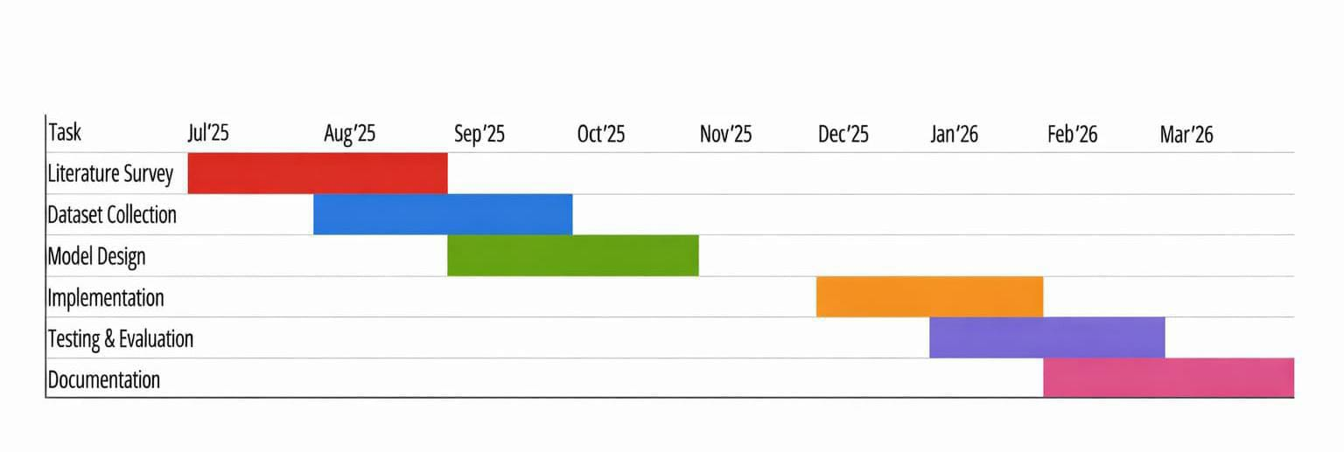
Figure 2.7 Gant Chart of Project Scheduling
Project Planning:
Project planning involves identifying the project activities, defining objectives, and organizing the sequence of tasks required to complete the project successfully.

Time Management:
Time management ensures that each activity in the project is completed within the planned schedule by allocating appropriate time for every phase such as literature survey, data collection, model development, and testing.

cdcxdccTask scheduling refers to arranging the project activities in a systematic order with specific start and end periods. The Gantt chart helps visualize when each task begins and ends, ensuring smooth execution of the project.

3.SYSTEM ARCHITECTURE & DESIGN

3.1 PROJECT ARCHITECTURE

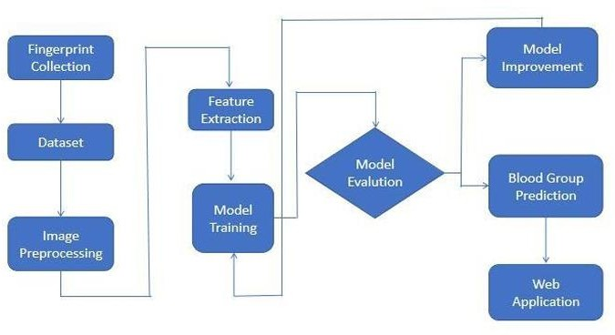

Figure 3.1 Project Architecture of Blood Group Detection using Fingerprint

3.2 DESCRIPTION
The architecture of the “Blood Group Detection Using Fingerprint” system is designed to integrate biometric image acquisition, image processing, feature extraction, machine learning classification, and result display into a single automated workflow. The architecture follows a modular and layered design, ensuring efficiency, scalability, and accuracy in detecting blood groups from fingerprint patterns.

- Input Module (Fingerprint Acquisition)
This is the first stage of the system, where the fingerprint of the user is captured using a biometric fingerprint scanner. The scanner records the unique ridge patterns, loops, whorls, and arches of the fingerprint and stores the image in a digital format (usually in grayscale). The quality of the captured fingerprint is crucial, as it directly affects the accuracy of further analysis.

2.Image Preprocessing Module
The acquired fingerprint image undergoes several preprocessing steps to enhance its quality and remove noise. Techniques such as image normalization, histogram equalization, and Gaussian filtering are applied to improve contrast and clarity. The Region of Interest (ROI) is extracted to focus on the essential ridge area. This step ensures that the image is standardized for accurate feature extraction.

3.3 DATA FLOW DIAGRAM
A Data Flow Diagram (DFD) is a graphical representation that illustrates how data flows within the system Non-Invasive Blood Group Classification Using Fingerprint Images and Deep Residual Learning. It visually explains how fingerprint data is captured, processed using deep learning, classified, stored, and displayed to the user.In this project, the DFD helps stakeholders understand how fingerprint images are transformed into blood group predictions using a Deep Residual Network such as ResNet.
These represent operations performed on data:
1.Fingerprint Image Acquisition
Captures fingerprint from scanner
2.Image Prepossessing Noise removal Enhancement Normalization
3.Feature Extraction using Deep Residual Learning
Extracts deep ridge features Uses trained Res Net model
4.Blood Group Classification
Classifies into A, B, AB, O (Positive/Negative)
5.Result Generation & Storage
Displays result
Stores data in database

Benefits:
The Data Flow Diagram (DFD) plays a crucial role in the Non-Invasive Blood Group Classification Using Fingerprint Images and Deep Residual Learning project by clearly visualizing the complete workflow from fingerprint acquisition to blood group prediction. It helps in understanding how the fingerprint image is captured, preprocessed, analyzed using deep learning models such as Res Net, and finally classified into a specific blood group. By mapping each step of the process, the DFD assists in identifying inefficiencies or bottlenecks in modules like prepossessing or classification, allowing improvements in system performance.
It also enhances communication between developers, researchers, and stakeholders by providing a simple visual representation that can be understood by both technical and non- technical audiences. Furthermore, since the project deals with biometric and medical-related data, the DFD ensures clarity in how sensitive fingerprint information is handled, stored, and secured within the system. Overall, it serves as an important tool for system documentation, project presentation, and maintaining secure and efficient data processing.

Applications:
The Data Flow Diagram (DFD) is highly useful in multiple application areas of the Non-Invasive Blood Group Classification Using Fingerprint Images and Deep Residual Learning project. In software development, it supports the design and structuring of AI-based classification systems by clearly defining how fingerprint data moves through prepossessing, feature extraction, and classification stages.
In healthcare technology, the DFD helps model non-invasive diagnostic systems, enabling a clear understanding of how biometric input is transformed into medical predictions without physical blood sampling. From a cybersecurity perspective, it assists in ensuring the safe storage and secure handling of sensitive fingerprint data by clearly mapping data storage points and transmission paths. Additionally, in business process modeling, the DFD provides insight into the automated classification workflow, helping organizations understand system operations, optimize performance, and eliminate bottlenecks. Overall, the DFD enhances clarity, efficiency, and security across all these domains

Levels of DFD:

Level 1 DFD
- Image Acquisition
- Image Preprocessing
- Deep Residual Feature Extraction
- Classification
- Storage & Result Display

Level 2 DFD (If Required)

- Further breaks down:
- Preprocessing into filtering, normalization, segmentation
- Classification into feature vector creation + softmax prediction
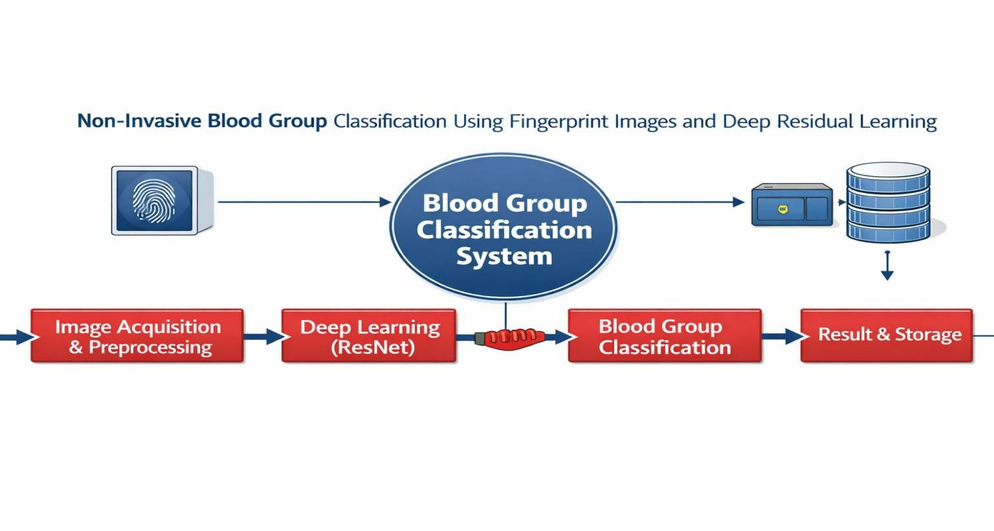
- Database module into storage and retrieval.
Figure 3.2 Dataflow Diagram of Non-Invasive Blood Group Classification Using Fingerprint Images and Deep Residual Learnin

4.IMPLEMENTATION
The implementation of the project titled “Non-Invasive Blood Group Classification Using Fingerprint Images and Deep Residual Learning” focuses on predicting a person’s blood group by analyzing fingerprint patterns using deep learning techniques. The system begins with the collection of fingerprint images along with their corresponding blood group labels (A+, A−, B+, B−, AB+, AB−, O+, O−). The dataset is organized into separate folders based on blood group classes. Image preprocessing is performed to enhance the quality and consistency of the data. This includes resizing all fingerprint images to a fixed dimension (e.g., 224×224 pixels), converting them to grayscale if required, normalizing pixel values, and applying noise reduction or contrast enhancement techniques. Data augmentation methods such as rotation, flipping, and zooming are also applied to increase dataset diversity and improve model generalization.

4.1 ALGORITHMS USED

CNN-Based Models for Feature Extraction
Convolutional Neural Networks (CNN) are widely used for fingerprint image classification because they are highly effective at capturing fine spatial features such as ridge patterns, textures, and minutiae structures. Models such as ResNet-50, VGG-16, and other deep CNN architectures are employed to analyze fingerprint images and determine the corresponding blood group. In particular, ResNet-50, based on deep residual learning introduced by Kaiming He, extracts hierarchical spatial features from fingerprint images for accurate blood group prediction. By identifying subtle ridge orientations, density variations, and texture patterns, CNNs help recognize distinguishing characteristics associated with different ABO and Rh blood groups. These extracted features are then passed to fully connected layers with softmax activation, which classify the fingerprint into one of the eight blood group categories (A+, A−, B+, B−, AB+, AB−, O+, O−), thereby improving prediction accuracy in a non- invasive and automated manner.

Advantages of CNN-Based Models:

  - CNNs automatically learn important fingerprint features such as ridges, textures, and patterns without manual feature engineering.
  - Fingerprint images contain subtle ridge variations; CNNs effectively detect fine- grained spatial details.
  - Eliminates manual analysis of fingerprint patterns, making the system more reliable and consistent.

Disadvantages of CNN-Based Models:

  - Deep CNN models require powerful GPUs and high processing power for training
  - CNNs need a large number of labeled fingerprint images for better accuracy and generalization.

Random Forest (RF) for Improved Classification

Random Forest (RF) is a supervised machine learning algorithm used for classification and regression tasks. In fingerprint-based blood group prediction, Random Forest helps improve classification accuracy by combining the predictions of multiple decision trees.

Why Use Random Forest?

- Random Forest combines multiple decision trees and uses majority voting, which increases prediction accuracy compared to a single decision tree.
- Unlike individual decision trees, Random Forest reduces overfitting by averaging multiple models, making it more stable and generalizable
- Fingerprint features (ridge count, texture, minutiae patterns) may have complex relationships with blood groups. RF effectively handles such non-linear patterns.
- After feature extraction (e.g., ridge density, orientation, pattern type), the data becomes numerical. Random Forest performs very well on this type of structured dataset.
- Fingerprint images may contain noise or slight variations. RF is less sensitive to noisy data compared to many other classifiers.

3.Support Vector Machine (SVM):
Support Vector Machine (SVM) is a supervised machine learning algorithm used for classification and regression tasks. In the topic SVM is used to classify extracted fingerprint features into different blood group categories (A, B, AB, O with Rh factor)
Nowadays, fingerprint-based non-invasive blood group prediction has gained significant attention as an alternative to traditional laboratory testing methods. Conventional blood group detection requires blood sampling, laboratory reagents, and trained personnel, which can be time-consuming and invasive. To overcome these limitations, a deep learning-based framework is employed to automatically analyze fingerprint images and predict blood group categories (A+, A−, B+, B−, AB+, AB−, O+, O−)
To address this problem, it employ a combination of Convolutional Neural Networks (CNNs) and advanced classification algorithms to improve prediction accuracy. A pre-trained deep residual learning model, ResNet-50, is used to extract rich spatial features from fingerprint images. ResNet-50, originally proposed by Kaiming He, is pre-trained on large- scale image datasets and is fine-tuned for fingerprint-based blood group classification. The CNN automatically learns discriminative ridge patterns, texture variations, and minutiae- based representations without manual feature engineering
In the proposed work, a novel deep learning-based architecture is designed for automated blood group classification. The framework first employs a pre-trained CNN model (ResNet- based architecture) to extract high-level fingerprint descriptors. These extracted feature vectors are then fed into classification layers such as fully connected networks or machine learning classifiers (e.g., Random Forest or SVM) to perform multiclass blood group prediction. The integration of transfer learning significantly improves feature learning capability and reduces training time.
To further enhance classification performance, advanced optimization techniques and regularization methods are incorporated during training. Data augmentation (rotation, flipping, scaling) is applied to improve generalization and handle variations in fingerprint orientation and quality.
Experimental results show that the deep residual CNN model achieves higher classification accuracy compared to the traditional SVM classifier. While SVM performs well with structured handcrafted features, it lacks the ability to automatically learn complex hierarchical patterns present in fingerprint images.

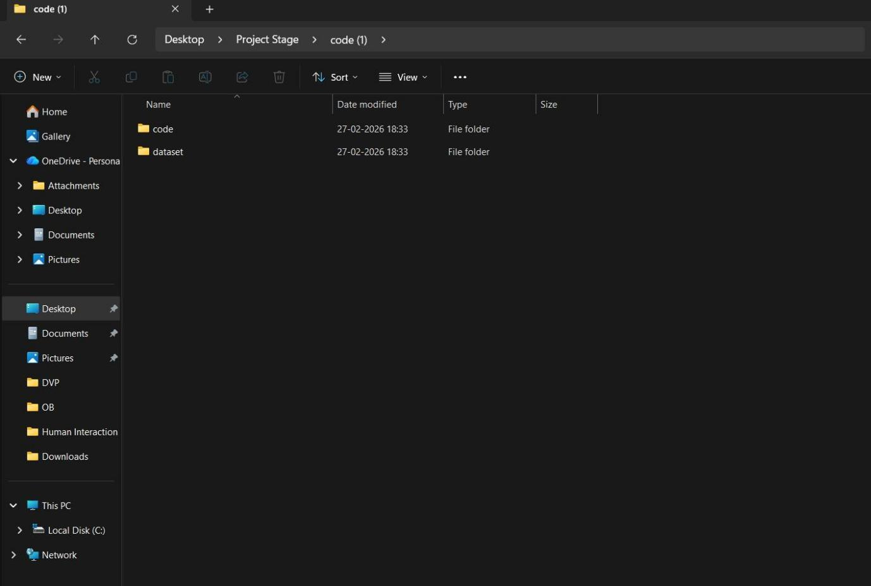
Figure 4.1.1 Dataset directory structure with folders 'Safe Content and Inappropriate Content' having all the training examples
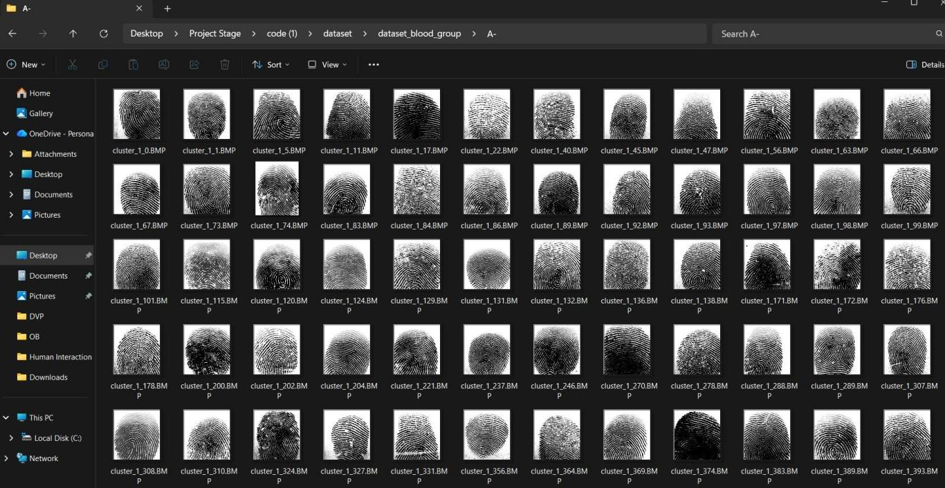
Figure 4.1.2 Screenshot of the "A- Negative" Folder Showing Sample Image Files

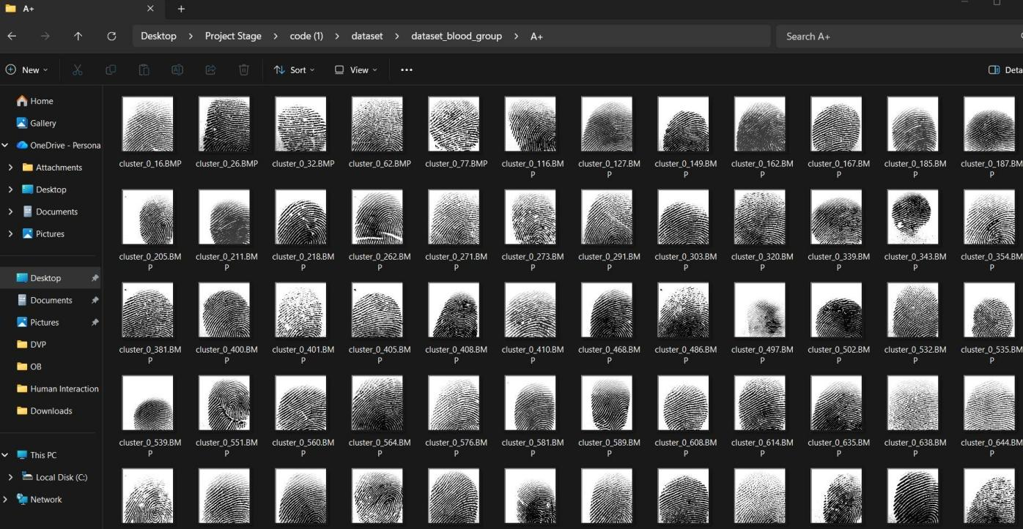
Figure 4.1.3 Screenshot of the "A+ Positive" Folder Showing Sample Image Files.

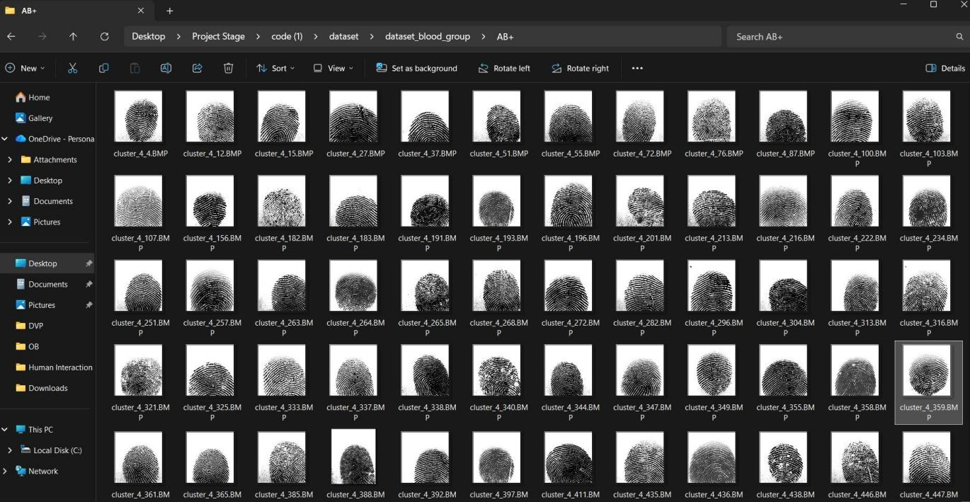

Figure 4.1.4 Screenshot of the "AB+ Positive" Folder Showing Sample Image Files.

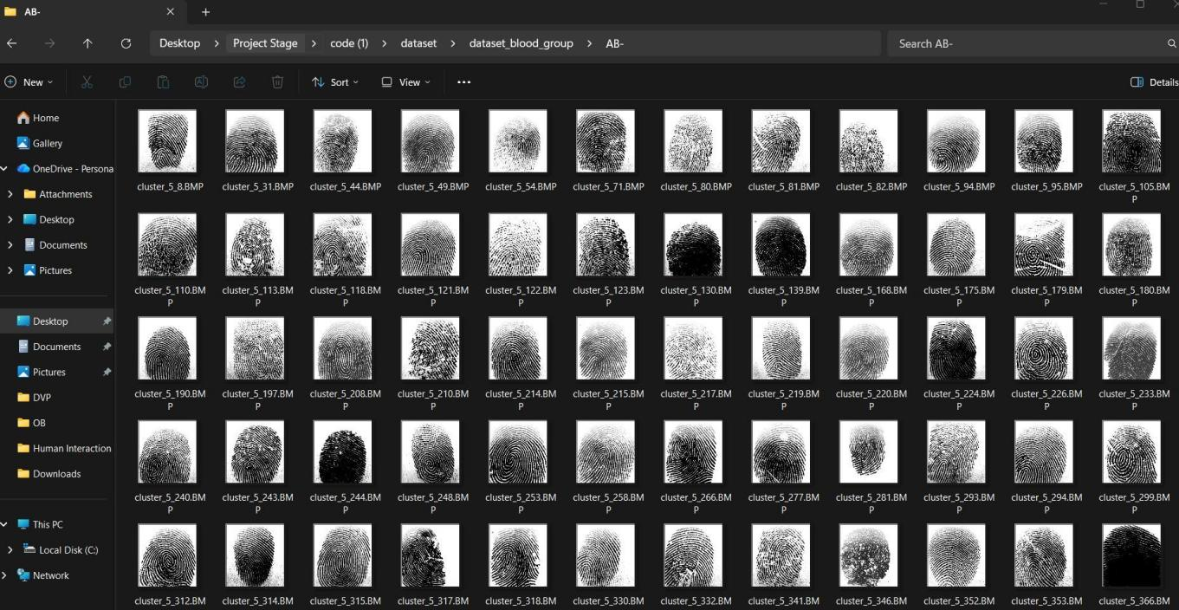

Figure 4.1.5 Screenshot of the "AB- Negative" Folder Showing Sample Image Files.
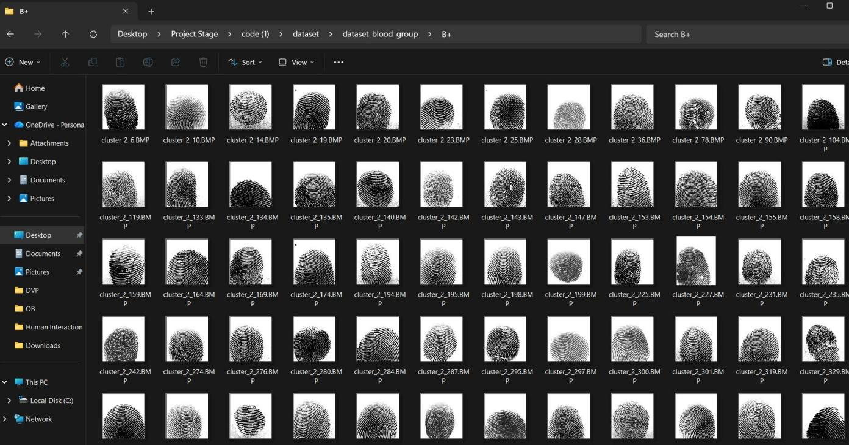
Figure 4.1.6 Screenshot of the "B+ Positive" Folder Showing Sample Image Files

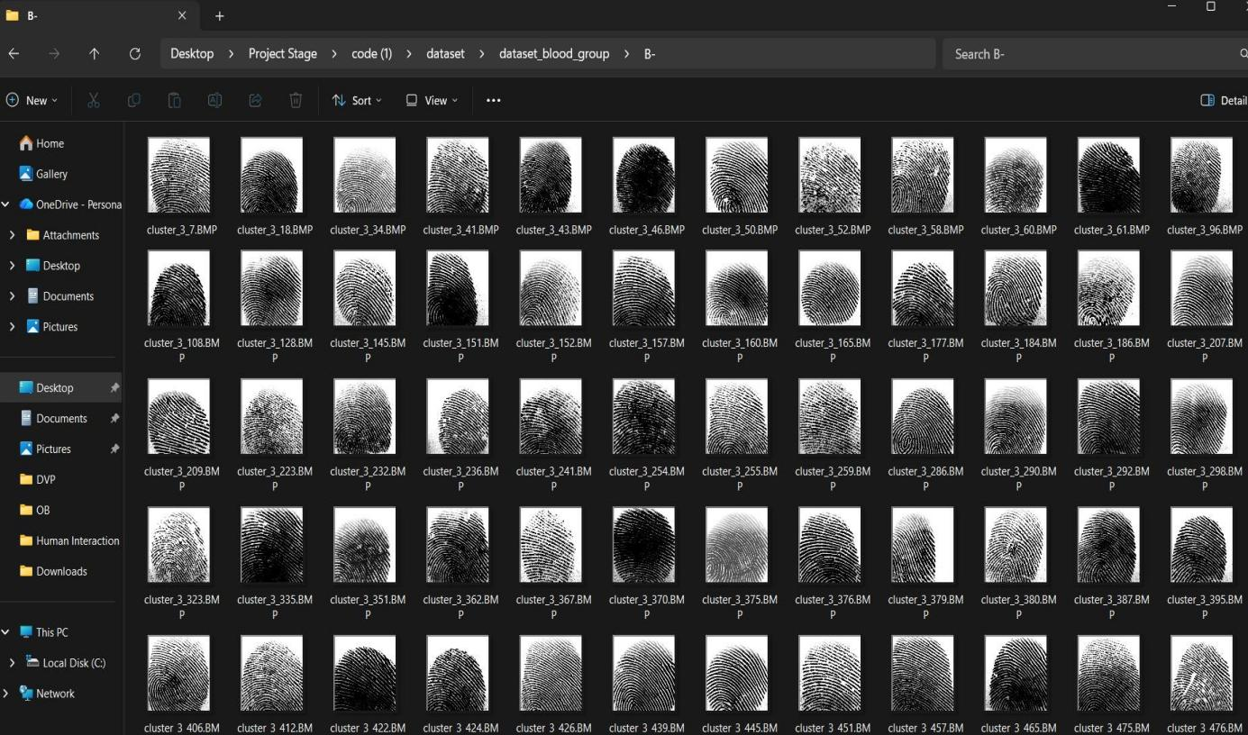
Figure 4.1.7 Screenshot of the "B-Negative" Folder Showing Sample Image Files.
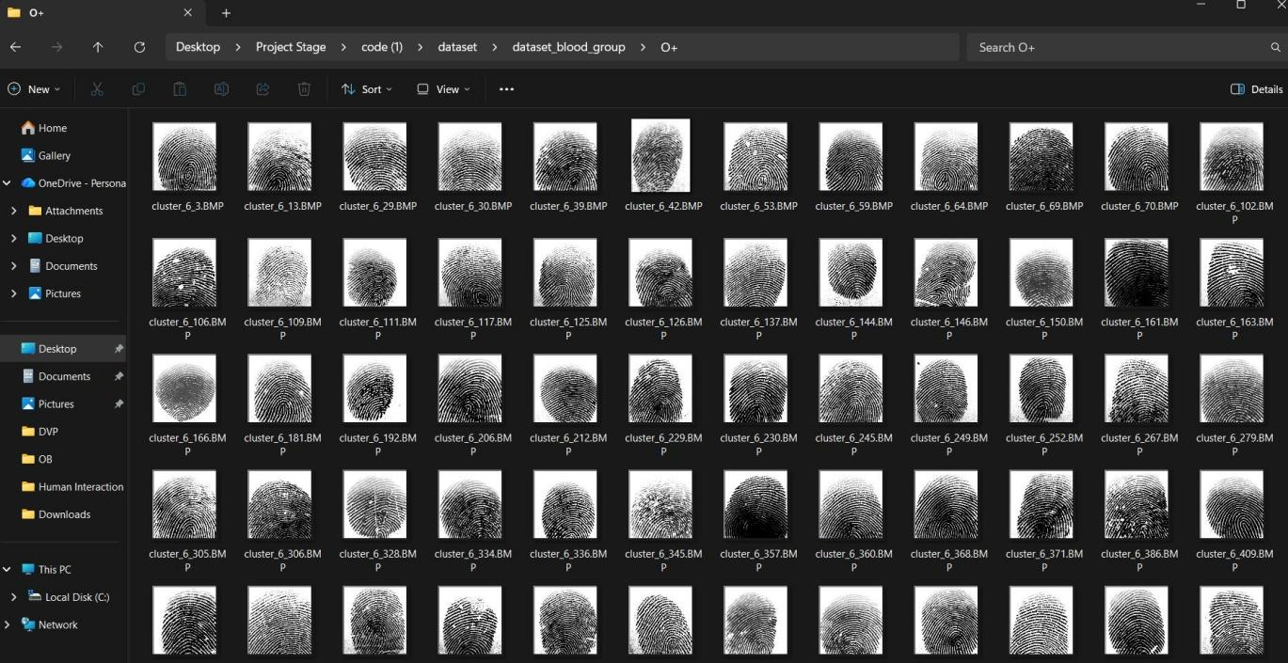

Figure 4.1.8 Screenshot of the "O+Positive" Folder Showing Sample Image Files.

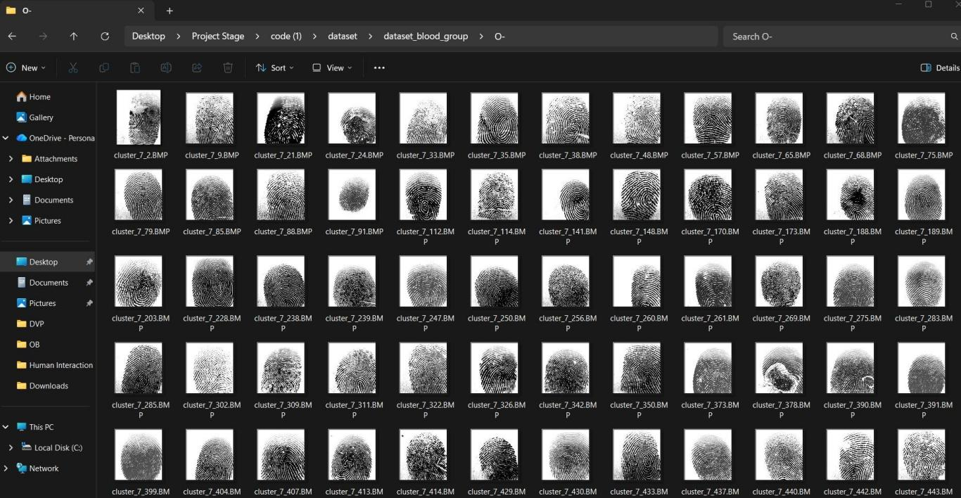

Figure 4.1.9 Screenshot of the "O-Negative" Folder Showing Sample Image Files.

4.2 SAMPLE CODE

import os
import numpy as np
from flask import Flask, render_template, request, redirect, url_for, flash from werkzeug.utils import secure_filename
from tensorflow.keras.models import load_model from tensorflow.keras.preprocessing import image
from tensorflow.keras.applications.imagenet_utils import preprocess_input

app = Flask( name )
app.secret_key = "change_this_secret_key"

UPLOAD_FOLDER = "static/uploads"
ALLOWED_EXTENSIONS = {"png", "jpg", "jpeg", "bmp", "webp"}

app.config["UPLOAD_FOLDER"] = UPLOAD_FOLDER
os.makedirs(UPLOAD_FOLDER, exist_ok=True)

labels_map = {'A+': 0, 'A-': 1, 'AB+': 2, 'AB-': 3, 'B+': 4, 'B-': 5, 'O+': 6, 'O-': 7}
idx_to_label = {v: k for k, v in labels_map.items()}

MODEL_DIR = "model_weights" MODELS = {
"resnet": {
"display": "ResNet",
"path": os.path.join(MODEL_DIR, "Resnet_blood_group_detection.h5"), "target_size": (256, 256),
"preprocess": "imagenet",
},
"lenet": {
"display": "LeNet",

"path": os.path.join(MODEL_DIR, "model_blood_group_detection_lenet.keras"), "target_size": (224, 224),
"preprocess": "scale01",
},
"alexnet": {
"display": "AlexNet",
"path": os.path.join(MODEL_DIR, "model_blood_group_detection_alextnet.keras"), "target_size": (256, 256),
"preprocess": "imagenet",
},
"vgg16": {
"display": "VGG16",
"path": os.path.join(MODEL_DIR, "blood_group_detection.h5"), "target_size": (256, 256),
"preprocess": "imagenet",
},
}

MODEL_CACHE = {}

def allowed_file(filename: str) -> bool:
return "." in filename and filename.rsplit(".", 1)[1].lower() in ALLOWED_EXTENSIONS

def get_model(model_key: str):
if model_key not in MODEL_CACHE: model_path = MODELS[model_key]["path"] if not os.path.exists(model_path):
raise FileNotFoundError(f"Model file not found: {model_path}") MODEL_CACHE[model_key] = load_model(model_path)
return MODEL_CACHE[model_key]

def prepare_image(img_path: str, target_size=(256, 256), preprocess_type="imagenet"): img = image.load_img(img_path, target_size=target_size)

x = image.img_to_array(img) x = np.expand_dims(x, axis=0)

if preprocess_type == "imagenet": x = preprocess_input(x)
elif preprocess_type == "scale01": x = x / 255.0
else:
x = x.astype("float32") return x
def predict_with_model(model_key: str, img_path: str): cfg = MODELS[model_key]
model = get_model(model_key)

x = prepare_image( img_path,
target_size=cfg["target_size"], preprocess_type=cfg["preprocess"],
)

preds = model.predict(x, verbose=0) preds = np.array(preds)

if preds.ndim == 2: probs = preds[0]
else:
probs = preds.reshape(-1)

idx = int(np.argmax(probs))
label = idx_to_label.get(idx, str(idx)) confidence = float(probs[idx]) * 100.0

return label, confidence

@app.route("/", methods=["GET"]) def home():
model_options = [{"key": "all", "name": "All Models"}] + [
{"key": k, "name": MODELS[k]["display"]} for k in MODELS
]
return render_template("index.html", model_options=model_options)

@app.route("/predict", methods=["POST"]) def predict():
if "file" not in request.files: flash("No file part in request.") return redirect(url_for("home"))

file = request.files["file"]
selected = request.form.get("model_choice", "all")

if file.filename == "": flash("No file selected.")
return redirect(url_for("home"))

if not allowed_file(file.filename):
flash("Invalid file type. Please upload png/jpg/jpeg/bmp/webp.") return redirect(url_for("home"))

filename = secure_filename(file.filename)
save_path = os.path.join(app.config["UPLOAD_FOLDER"], filename) file.save(save_path)

image_url = url_for("static", filename=f"uploads/{filename}")

model_options = [{"key": "all", "name": "All Models"}] + [
{"key": k, "name": MODELS[k]["display"]} for k in MODELS

]

results = [] try:
if selected == "all":
for mk in MODELS:
label, conf = predict_with_model(mk, save_path) results.append({
"model_key": mk,
"model_name": MODELS[mk]["display"], "label": label,
"confidence": f"{conf:.2f}"
})
else:
if selected not in MODELS: flash("Invalid model selection.") return redirect(url_for("home"))

label, conf = predict_with_model(selected, save_path) results.append({
"model_key": selected,
"model_name": MODELS[selected]["display"], "label": label,
"confidence": f"{conf:.2f}"
})

except Exception as e: flash(f"Prediction failed: {e}") return redirect(url_for("home"))

return render_template( "index.html", model_options=model_options, selected_model=selected,

image_url=image_url, results=results,
)

if name == " main ":
app.run(debug=False,host="0.0.0

5.RESULTS & DISCUSSION

The following screenshots showcase the results of our project, highlighting key features and functionalities. These visual representations provide a clear overview of how the system performs under various conditions, demonstrating its effectiveness and user interface. The screenshots serve as a visual aid to support the project's technical and operational achievements.
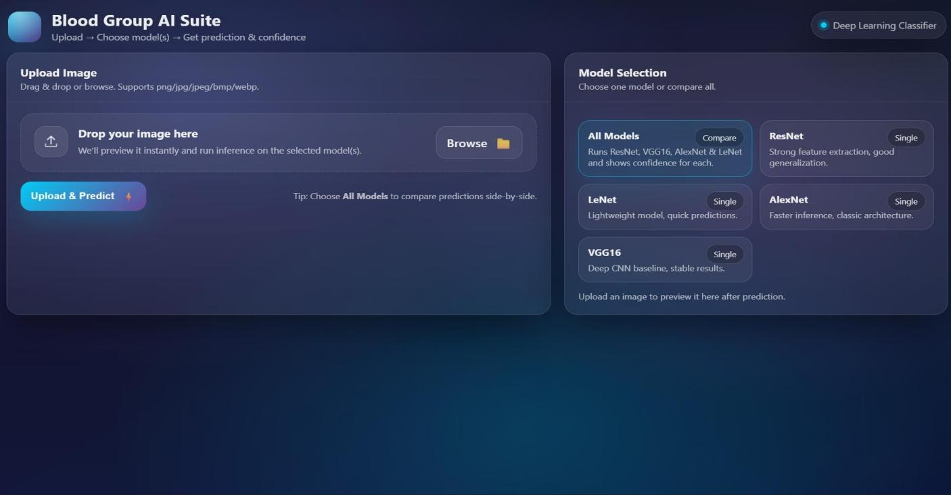

Figure 5.1 GUI/Main Interface of Non-Invasive Blood Group Classification Using Fingerprint Images and Deep Residual Learning

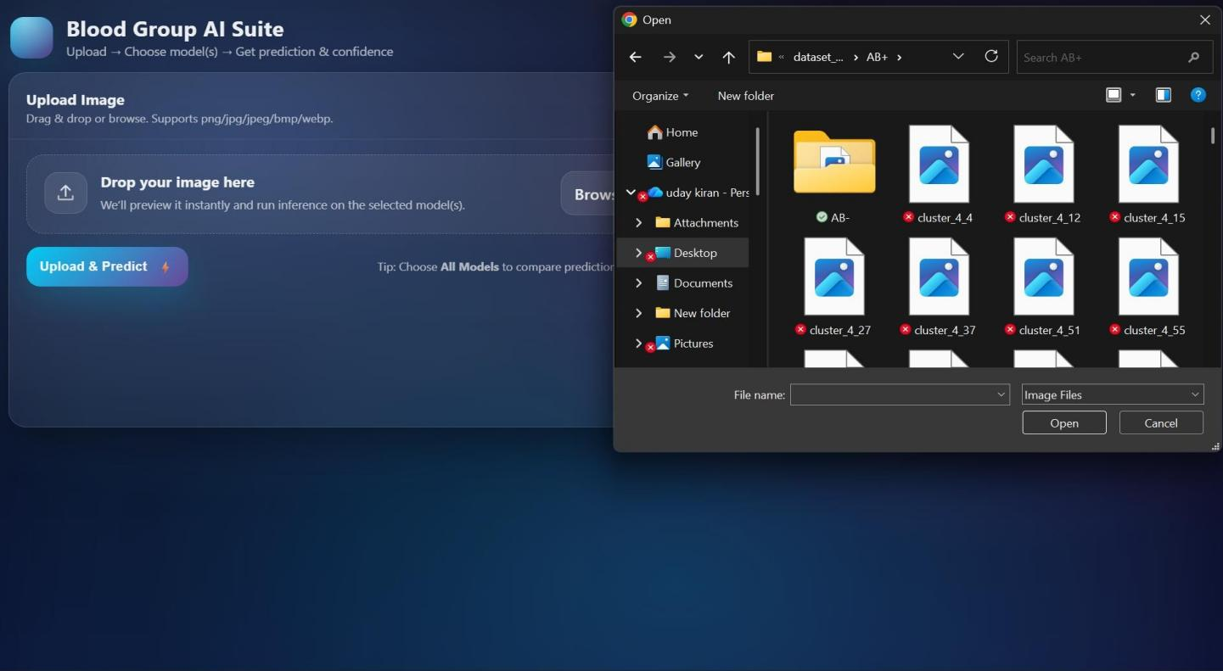
Figure 5.2 Loaded sample image of Non-Invasive Blood Group Classification Using Fingerprint Images and Deep Residual Learning

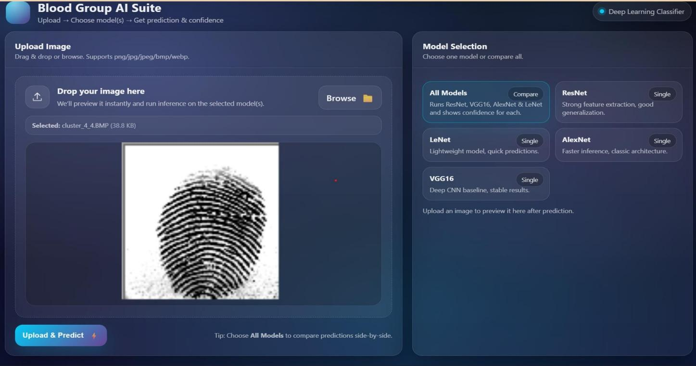
Figure 5.3 Dataset of Non-Invasive Blood Group Classification Using Fingerprint Images and Deep Residual Learning

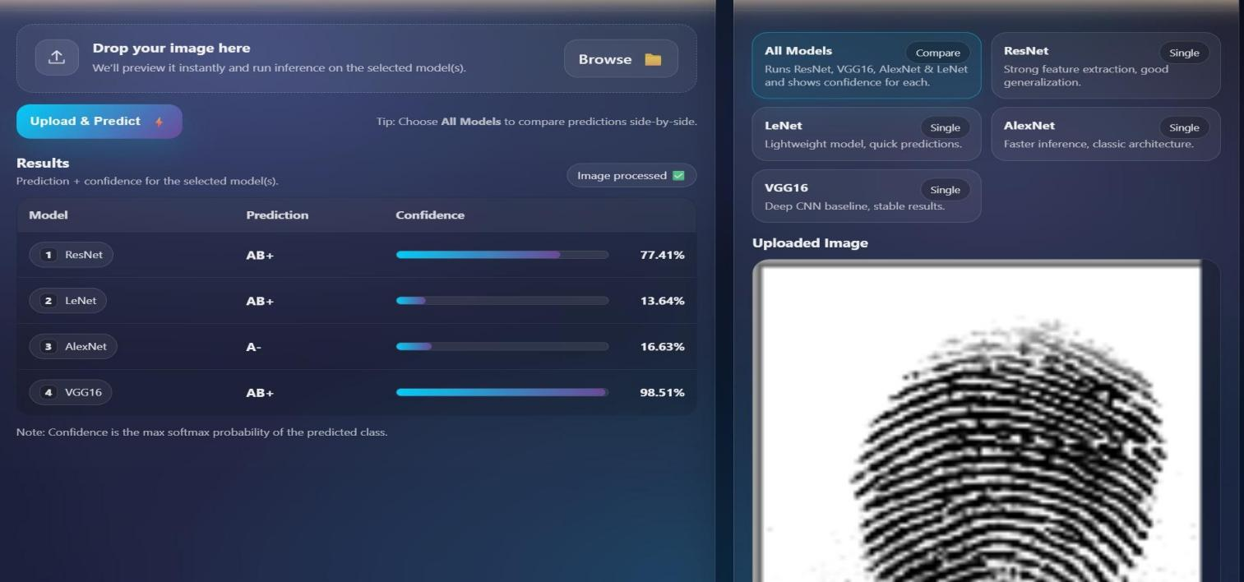
Figure 5.4 Representation of Non-Invasive Blood Group Classification Using Fingerprint Images and Deep Residual Learning with Accuracy
and Prediction.

6.VALIDATION

The validation of the project primarily relies on systematic testing and clearly defined evaluation procedures to ensure the accuracy, reliability, and effectiveness of the blood group prediction system. The validation process is conducted in multiple stages, including data set validation, model performance evaluation, and real-time testing.

6.1 INTRODUCTION
The fingerprint data set is carefully divided into training and testing sets, typically using an 80–20 split. The training set is used to train the deep learning model, while the testing set is utilized to evaluate its generalization capability on unseen fingerprint images. To further enhance reliability, K-fold cross-validation is performed, ensuring that the system is validated on multiple data partitions. This approach minimizes over fitting and improves the robustness of the model, confirming that it can generalize effectively to new individuals.

The accuracy of the system is measured using important performance metrics such as accuracy, precision, recall, F1-score, and confusion matrix analysis. The confusion matrix provides detailed insights into correct and incorrect blood group classifications (A, B, AB, and O), helping to identify miscalculation patterns and refine the model for improved performance. In addition, the proposed Deep Residual Learning model based on Res Net, developed by Microsoft Research, is compared with other machine learning approaches to demonstrate its superior feature extraction capability and higher classification accuracy.

Finally, real-world testing is conducted using new fingerprint samples that were not included in the training or validation data sets. This stage simulates practical healthcare scenarios to ensure that the system performs reliably in real-time applications. Continuous improvements are implemented based on validation and testing results to enhance accuracy and stability. This structured validation methodology ensures that the proposed non-invasive blood group classification system is reliable, scalable, and capable of maintaining high prediction accuracy in real-world medical environments.

6.2 TEST CASES

TABLE NO 6.2.1 UPLOADING DATASET TABLE

Test case ID | Test case name | Purpose | Test Case | Output
1 | User Upload  Dataset | Use it for content prediction | The user upload the Data set,on which the content is detected | Dataset Successfully loaded

TABLE NO 6.2.2 CLASSIFICATION TABLE

1 | Classification test 1 | To check if the classifier performs its task | Safe-Content file is selected | Safe Content..
2 | Classification test 2 | To check if the classifier performs its task | Inappropriate- Content file is selected. | Inappropriate Content

7.CONCLUSION & FUTURE ASPECTS
In conclusion, the project has successfully achieved its primary objectives by developing an efficient, accurate, and non-invasive method for blood group prediction. The design, implementation, and validation phases were systematically planned and carefully executed, resulting in meaningful performance improvements and reliable classification outcomes. By utilizing Deep Residual Networks (Res Net), introduced by Microsoft Research, the system effectively extracted complex fingerprint features and demonstrated strong generalization capability through structured validation techniques. The results highlight the feasibility of combining biometric analysis with deep learning for health care applications.

7.1PROJECT CONCLUSION

This research presents an effective and intelligent deep learning framework for achieving high validation accuracy and reliable classification performance. The proposed system leverages Deep Residual Networks (ResNet), originally introduced by Microsoft Research, to perform advanced spatial feature extraction from fingerprint images. The residual learning mechanism successfully overcomes the vanishing gradient problem, enabling deeper architectures to learn complex ridge patterns and biometric features associated with different blood groups (A, B, AB, and O)
The model addresses limitations of traditional machine learning approaches by automatically learning hierarchical features instead of relying on handcrafted feature extraction methods. Through structured validation techniques such as train-test splitting, K- fold cross-validation, and performance metric evaluation (accuracy, precision, recall, F1- score, and confusion matrix), the system ensures strong generalization capability while minimizing overfitting. The use of regularization techniques and optimized hyperparameters further enhances model stability and computational efficiency.

7.2 FUTURE ASPECTS
The proposed system for has demonstrated promising accuracy and efficiency in predicting blood groups using biometric data. However, there remains substantial scope for further enhancement to strengthen its clinical reliability, scalability, and real-world applicability. Future advancements in deep learning architectures, dataset expansion, deployment strategies, and ethical AI practices can significantly improve the robustness and impact of the system.These are some future aspect : By focusing on scalability, transparency, ethical AI practices, and clinical validation, the proposed framework can evolve into a reliable and widely adopted non-invasive diagnostic support system. These advancements will strengthen its practical impact and ensure long-term sustainability in AI-driven healthcare applications.To further enhance performance, incorporating advanced architectures such as transformer-based models and hybrid CNN approaches can improve feature extraction from fingerprint patterns. Increasing the size and diversity of the dataset, including data from different age groups, ethnicities, and environmental conditions, will help reduce bias and improve generalization.Integration with real-time systems such as mobile applications and IoT-based healthcare devices can make the solution more accessible, especially in remote and rural areas where traditional blood testing facilities are limited. Cloud-based deployment can also enable faster processing, scalability, and centralized data management.Clinical validation through collaboration with hospitals and medical professionals is essential to ensure the reliability and acceptance of the system in healthcare settings. Conducting large-scale trials and comparing results with standard laboratory methods will further strengthen trust in the model.In addition, incorporating explainable AI (XAI) techniques can improve transparency by providing insights into how predictions are made. This is crucial for gaining trust from medical practitioners and ensuring accountability in decision-making.From an ethical perspective, ensuring data privacy, secure storage, and compliance with healthcare regulations must be prioritized. Implementing strong encryption and anonymization techniques will help protect sensitive biometric data.Finally, continuous model updating through feedback mechanisms and real-world data can improve system performance over time. By focusing on scalability, transparency, ethical AI practices, and clinical validation, the proposed framework can evolve into a reliable and widely adopted non-invasive diagnostic support system. These advancements will strengthen its practical impact and ensure long-term sustainability in AI-driven healthcare applications.

8.BIBLIOGRAPHY

8.1 REFERENCES

- K. He, X. Zhang, S. Ren, and J. Sun, “Deep residual learning for image recognition,” in Proceedings of the IEEE Conference on Computer Vision and Pattern Recognition (CVPR), 2016, pp. 770–778, doi: 10.1109/CVPR.2016.90.

[2] Y. LeCun, Y. Bengio, and G. Hinton, “Deep learning,” Nature, vol. 521, no. 7553,
pp. 436–444, 2015, doi: 10.1038/nature14539.

[3] D. Maltoni, D. Maio, A. K. Jain, and S. Prabhakar, Handbo

- A. K. Jain, J. Feng, and K. Nandakumar, “Fingerprint matching,” IEEE Computer, vol. 43, no. 2, pp. 36–44, Feb. 2010.

[5] S. Wang, J. Sun, and L. Zhang, “Deep learning-based fingerprint classification and recognition,” Pattern Recognition Letters, vol. 125, pp. 100–106, 2019.
[6] S. Wang, J. Sun, and L. Zhang, “Deep learning-based fingerprint classification and recognition,” Pattern Recognition Letters, vol. 125, pp. 100–106, 2019.

[7] P. R. Shivhare, S. K. Sharma, S. K. Ray, A. Minj, and K. Saha, “Dermatoglyphic pattern in relation to ABO and Rh blood group and gender,” International Journal of Scientific Study, vol. 4, no. 11, pp. 61–65, 2017.

[8] S. Chaudhary, S. Deuja, M. Alam, P. Karmacharya, and M. Mondal, “Fingerprints as an alternative method to determine ABO and Rh blood groups,” JNMA Journal of Nepal Medical Association, vol. 56, no. 208, pp. 426–431, 2017.

[9] S. Manikandan, “Dermatoglyphics and their relationship with blood group: An exploration,” Journal of Pharmacy and Bioallied Sciences, 2019
[10] Sasidhar, B., et al. (2025). An Innovative Non-Invasive Blood Group Detection Using Fingerprint Images. Journal of Criminology and Forensic Studies (JOCFS), 7(1), 180087.
[11] Varlekar, D. M. D., Varlekar, D. B., & Patel, D. K. (2024). A Study of Relationship between Blood Type and Fingerprint Designs. European Journal of Cardiovascular Medicine, 14(4), 206-211.
[12] Sultan, R., Ul Ain, Q., & Mehveen, S. (2026). Blood Group Prediction Using Fingerprint Through Deep Learning. International Research Journal on Advanced Engineering Hub (IRJAEH), 2(7), 3056-3063.
[13] Sruthi, Pinamala,Suhasini R.Narasimha V,Chintalapudi, S. Rao ,Rao, D. T. V. Dharmajee,Mounika, P. “Random Forest Classifier Assessment on Liver Disease EstimatingThrough Smote-ENN Balancing for Precision and Complexity Matrix”, Cognitive Science and Technology,Springer, Singapore. (Also associated with Cybernetics, Human Cognition, and Machine Learning in Communicative AI, 2025)

[14] Aelgani, Vivekanand , Archana, K.Kamala, Meka,Rao, Chikati Madhava ,Baig, Maughal Ahmed Ali,Mahendar, A.”Retinal Image-Based Deep Learning Neural Network Approaches for Glaucoma Detection: Analysis on Improved Accuracy and Processing Power”,ICCCMLA 2024 - 6th International Conference on Cybernetics, Cognition and Machine Learning Application 19-20 October 2024.

[15] J.Avanija, Banothu Ramji, A. Prabhu, K. Maheswari, R. Hitesh Sai Vittal, D. B. V. Jagannadham & Voruganti Naresh Kumar “Interpretation of Brain Tumour using Deep Learning Model” ,Springer 4 International Conference on Computer & Communication [16 Technologies(IC3T-2022).

[16] Bhaskar, Nuthanakanti,Kiran, Jangala Sasi,Satyanarayan, Suma,Divya,GaddamRaju, Kotagiri Srujan Kanthi, Murali Patra, Raj Kumar: ”An approach for liver cancer detection from histopathology images using hybrid pre-trained models”,Telkomnika (Telecommunication Computing Electronics and Control)-20246

[17] C. Szegedy et al., “Going deeper with convolutions,” in Proceedings of the IEEE Conference on Computer Vision and Pattern Recognition (CVPR), 2015

[18] A. Krizhevsky, I. Sutskever, and G. E. Hinton, “ImageNet classification with deep convolutional neural networks,” Advances in Neural Information Processing Systems, vol. 25, 2012
.
[19] M. Sharif et al., “Deep learning-based biometric authentication systems: A survey,” IEEE Access, vol. 8, pp. 197661–197683, 2020

[20] Pimenta, Sara, Filomena Soares, and Graça Minas. "Development of an automatic electronic system to human blood typing." 2012 Annual International Conference of the IEEE Engineering in Medicine and Biology Society. IEEE, 2012

[21] Mondal, M., Suma, U. K., Katun, M., Biswas, R., & Islam, M. R. (2020, updated/cited in 2024-2026). Blood Group Identification Based on Fingerprint by Using 2D Discrete Wavelet and Binary Transform. Modelling, Measurement and Control C, 80(2-4), 40-44

[22] B. Rim, J. Kim, and M. Hong, “Fingerprint classification using deep learning approach,” Multimedia Tools and Applications, vol. 80, pp. 35809–35825, 2021. Springer

[23] Sasidhar, B., et al. (2025). An Innovative Non-Invasive Blood Group Detection Using Fingerprint Images. Journal of Criminology and Forensic Studies (JOCFS), 7(1), 180087.

[24] Varlekar, D. M. D., Varlekar, D. B., & Patel, D. K. (2024). A Study of Relationship between Blood Type and Fingerprint Designs. European Journal of Cardiovascular Medicine, 14(4), 206-211.

[25] Sultan, R., Ul Ain, Q., & Mehveen, S. (2026). Blood Group Prediction Using Fingerprint Through Deep Learning. International Research Journal on Advanced Engineering Hub (IRJAEH), 2(7), 3056-3063.

[26] Sruthi, Pinamala,Suhasini R.Narasimha V,Chintalapudi, S. Rao ,Rao, D. T. V. Dharmajee,Mounika, P. “Random Forest Classifier Assessment on Liver Disease EstimatingThrough Smote-ENN Balancing for Precision and Complexity Matrix”, Cognitive Science and Technology,Springer, Singapore. (Also associated with Cybernetics, Human Cognition, and Machine Learning in Communicative AI, 2025)

[27] Aelgani, Vivekanand , Archana, K.Kamala, Meka,Rao, Chikati Madhava ,Baig, Maughal Ahmed Ali,Mahendar, A.”Retinal Image-Based Deep Learning Neural Network Approaches for Glaucoma Detection: Analysis on Improved Accuracy and Processing Power”,ICCCMLA 2024 - 6th International Conference on Cybernetics, Cognition and Machine Learning Application 19-20 October 2024.

[28] J. Avanija, Banothu Ramji, A. Prabhu, K. Maheswari, R. Hitesh Sai Vittal, D. B. V. Jagannadham & Voruganti Naresh Kumar “Interpretation of Brain Tumour using Deep Learning Model” ,Springer 4 International Conference on Computer & Communication Technologies(IC3T-2022), https://link.springer.com/chapter/10.1007/978-981-19-8563-8_33,Kakatiya Institute Of Technology & Science, Warangal from 29.07.2022 to 30.07.2022. (Scopus)
[29] Bhaskar, Nuthanakanti,Kiran, Jangala Sasi,Satyanarayan, Suma,Divya,GaddamRaju, Kotagiri Srujan Kanthi, Murali Patra, Raj Kumar: ”An approach for liver cancer detection from histopathology images using hybrid pre-trained models”,Telkomnika (Telecommunication Computing Electronics and Control)-20246

8.2 GITHUB LINK
https://github.com/gousiya@112/Non-Inavasive Blood Group Classification using Fingerprint Images and Deep Residual Learning.

